Region and Zone

Azure Services:

1. Azure Virtual Machines. : nothing but VM's

- Virtual servers in Azure

Features:

- Create and manage lifecycle of virtual machine (VM) instance

- **Load balancing** and **auto scaling** for multiple VM instances

- **Attach Storage** to your VM instances

- Manage **network connectivity and configuration** for your VM instances

2.

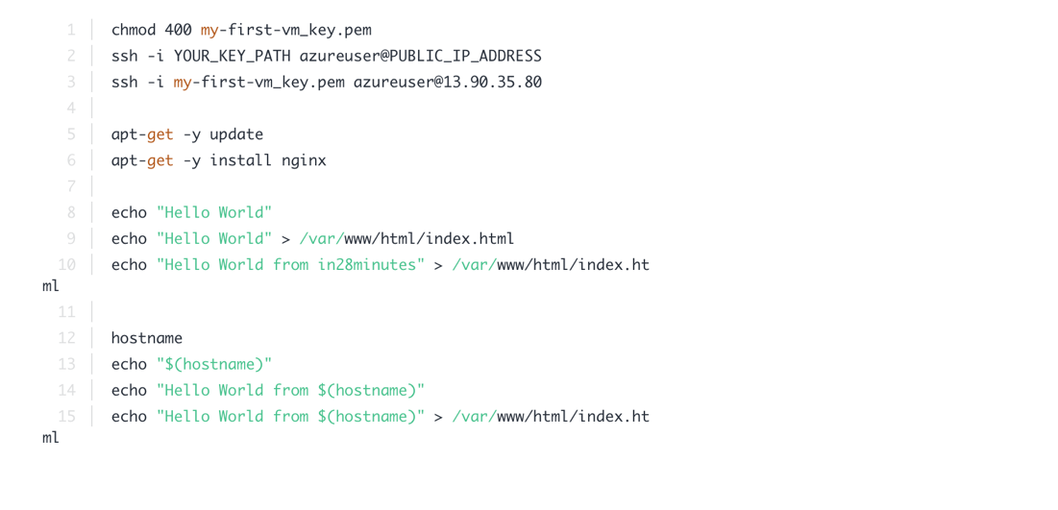

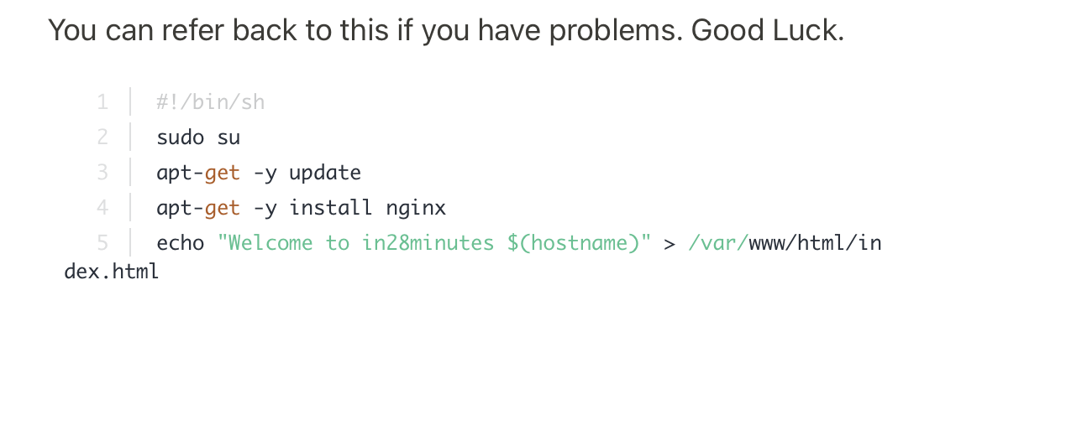

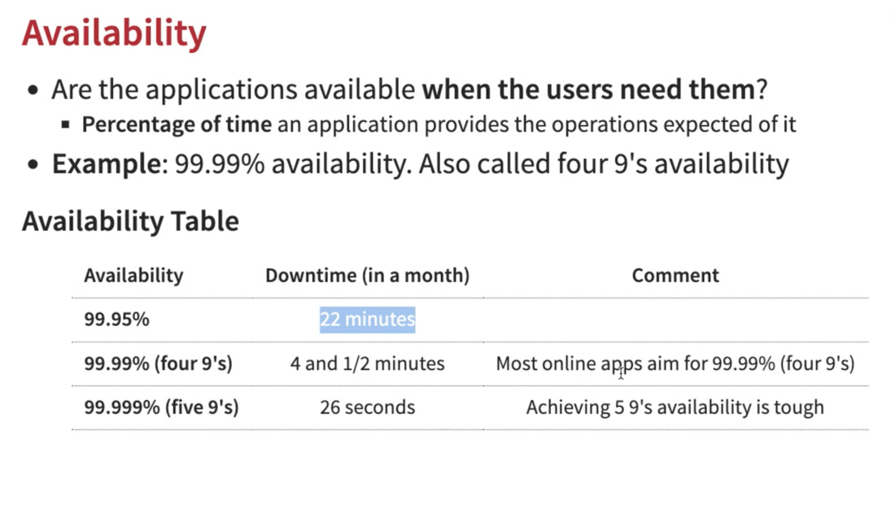

Virtual machine scale sets

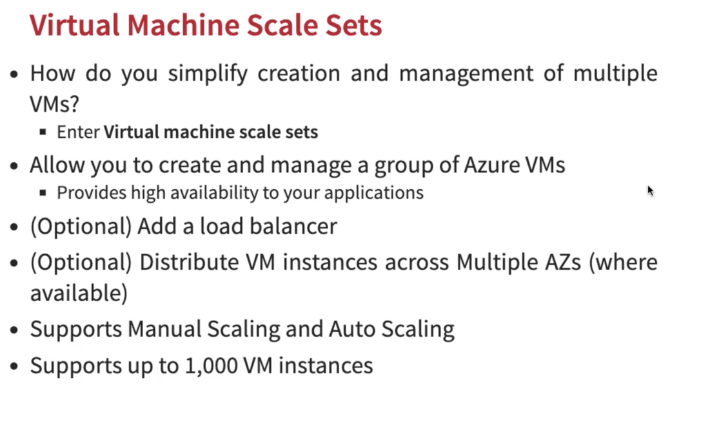

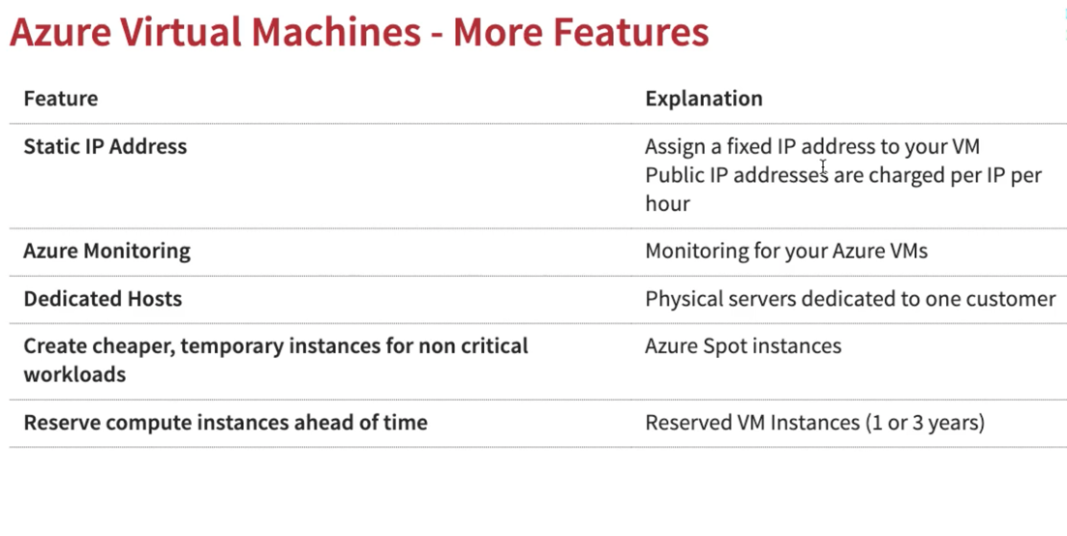

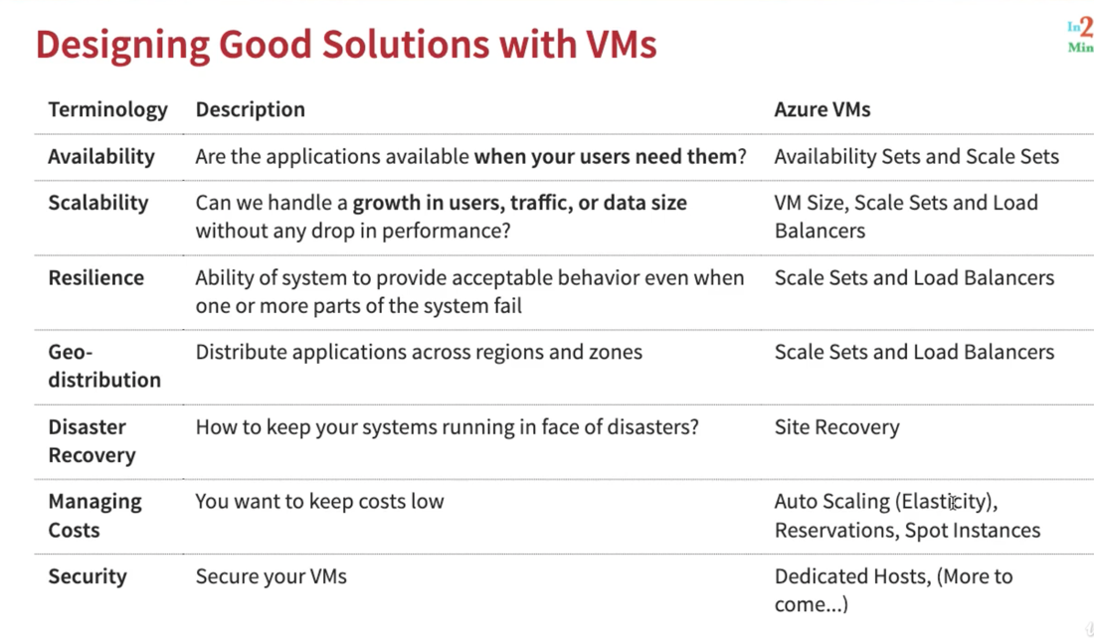

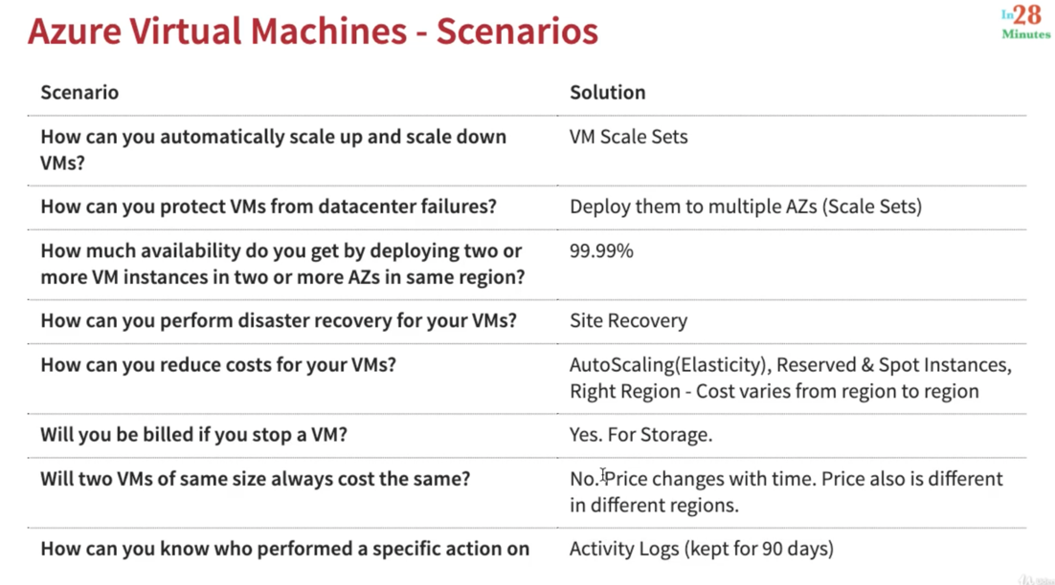

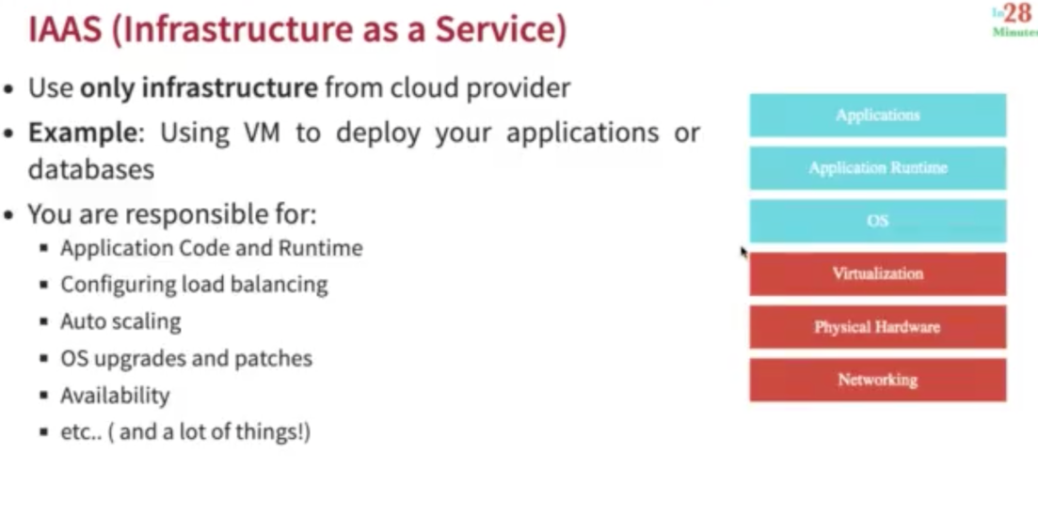

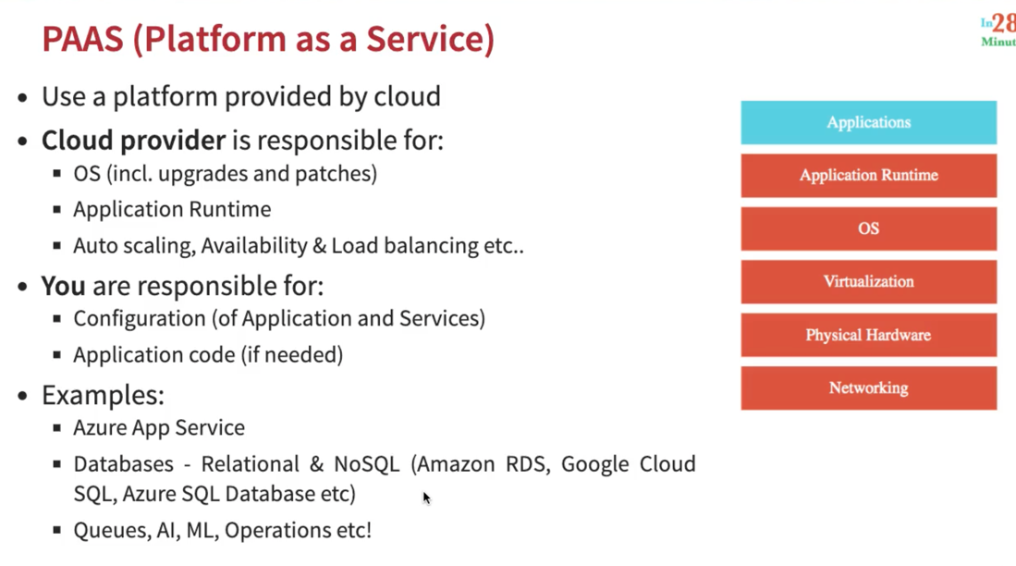

Platform as a service :

